

Going For The Gold!

INDIVIDUAL WALKING CHALLENGE

GOLD COAST OF FLORIDA





SIGN UP

REGISTER FOR THE CHALLENGE

1. Go to www.wellworksforyoulogin.com or download the Wellworks For You Mobile App
2. Click the register link and create an account
3. Enter your Company ID: **13294**
4. Select Yes to confirm the company name listed is correct
5. Create a Username and Password and enter the required Personal Information
6. Select Create Account
7. Accept the terms of the Consent Form
8. Click **Challenges** from the portal homepage
9. Select the **Going for the Gold Challenge** to view the challenge dashboard
10. Click **Activate** to become an active participant in the walking challenge
11. Select how you would like to appear on the leaderboard

*\*Google Chrome is the recommended browser when participating in challenges on the Wellness Portal.*

PARTICIPATE

**Choose one (1) of the options below to track your steps:**

* **Fitbit Pedometer:** Make sure your Fitbit is registered on [**www.fitbit.com**](http://www.fitbit.com/) and synced on the Wellness Portal by clicking **MENU> Device/App Connect>Connect Device/App**
* **Devices and Apps**: Sync your device or everyday fitness app to the Wellness Portal by clicking **MENU>Device/App Connect>Connect Device/App**. Locate your device and follow the prompts to sync with the Wellness Portal
* **Manually Track Steps**: Track your steps in the Challenge Dashboard by clicking the **+ Track Steps** button located under the My Progress section
* **Apple Health: Apple users must sync via the Wellworks For You mobile app to transfer data from the Apple Health App and Apple Watch**

***\*Sync only one (1) device/app for accurate step counts. Manually entering steps will override any existing steps for that day, even if they came from a device/app.***

OVERALL PRIZE!

* The top 3 people on the leaderboard at the conclusion of the challenge will receive a prize!

**APRIL 22, 2024 – MAY 19, 2024**

*Join your coworkers on a virtual walking trip to Florida’s Gold Coast! We will begin our 4-week journey in Jupiter and make our way to Miami! We do not expect you to complete the route – just use it as scenery throughout your journey!*

|  |  |
| --- | --- |
| Interval | Step Goal |
| April 22 – April 28 | Average **5,000** steps per day |
| April 29 – May 5 | Average **6,000** steps per day |
| May 6 – May 12 | Average **7,000** steps per day |
| May 13 – May 19 | Average **8,000** steps per day |

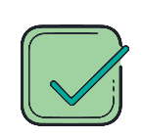

**BONUS PRIZE RAFFLE**

Each week during the challenge, we will randomly select 3 winners who have reached the steps goal for that week. Step goals for each week are listed above.





**PARTICIPATION MADE EASY**

*Easily sync your device, check the Challenge Leaderboard, track your step average, and even confirm your Wellness Program completion status with the Wellworks For You Mobile App!*

*Download through the Google Play or App Store to get started.*

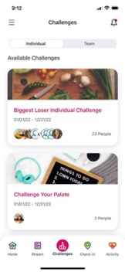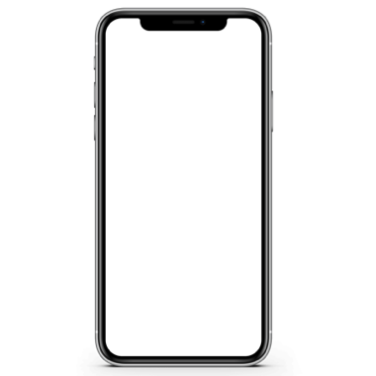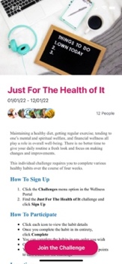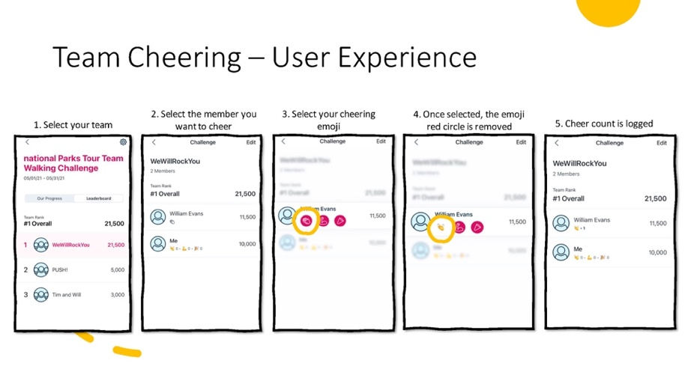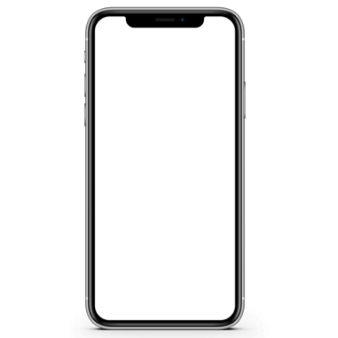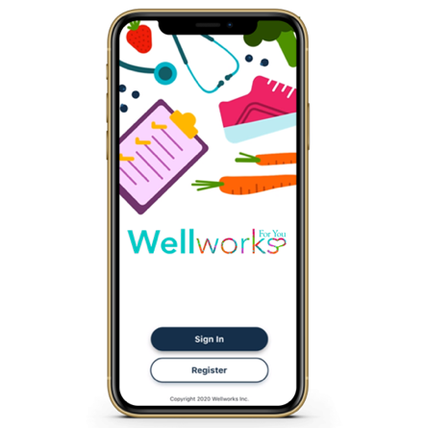

FAQs

HOW DO I SYNC MY DEVICE/APP TO THE WELLNESS PORTAL?

**ON THE WELLNESS PORTAL:**

Go to MENU>Device/App Connect. Click Connect Device/App. Then click Connectunder the icon for the device or app you want to sync to the Wellness Portal. Follow the prompts to get connected.

**ON THE WELLWORKS FOR YOU MOBILE APP:**

Download the **Wellworks For You** mobile app and login using your account credentials. Go to the menu at the top left corner and select **Devices.** Follow the prompts to get connected.

[**CLICK HERE**](https://www.wellworksforyoulogin.com/uploads/Toolbox/Device%20App-Sync%20Guide%20NO%20SAMSUNG_1022.pdf) to access the Device/App Connecting Instructions.

I AM HAVING TROUBLE CONNECTING MY DEVICE TO THE WELLWORKS PORTAL.

[**CLICK HERE**](https://www.wellworksforyoulogin.com/uploads/Toolbox/Device%20App%20Sync_Troubleshooting_1222Update.pdf) to access the Wellworks Device/App Troubleshooting Guide.

HOW DO I MANUALLY TRACK STEPS?

You can manually track your steps in the challenge dashboard by clicking the + Track Steps button located under the My Progress section. Please note, this option will be disabled if your challenge does not allow for manual step tracking.

HOW DO I CONVERT ACTIVITIES TO STEPS?

[CLICK HERE](https://www.wellworksforyoulogin.com/uploads/Toolbox/Activities%20To%20Steps%20Conversion%20Table%202021.pdf) to view an activity to steps conversion table.

HOW DO I LOG MY STEPS ON THE SMARTPHONE APP?

1. Log into the Wellworks For You mobile app.
2. Click the Challenges tile.
3. Choose the appropriate challenge.
4. Select Log Your Steps to enter your steps.

HAVE ADDITIONAL QUESTIONS?

Contact your dedicated Wellness Coordinator from the Contact Us page of your Wellness Portal or via phone at 800.425.4657.